Assignment: (Day-5) Cisco Packet Tracer - HomeWiFiNetwork Documentation
Project Name: HomeWiFiNetwork.pkt

Objective
Create a home Wi-Fi network consisting of one wireless router and three PCs, assign static IP addresses, configure the default gateway, and verify connectivity using ping.

Network Topology
[Insert Screenshot 1: Packet Tracer topology showing one wireless router connected to three PCs]

Devices Used
Device | Quantity
Wireless Router | 1
PC | 3

IP Addressing
Device | IP Address | Subnet Mask | Default Gateway
Router | 192.168.10.1 | 255.255.255.0 | -
PC0 | 192.168.10.2 | 255.255.255.0 | 192.168.10.1
PC1 | 192.168.10.3 | 255.255.255.0 | 192.168.10.1
PC2 | 192.168.10.4 | 255.255.255.0 | 192.168.10.1

Configuration Steps
- Open Cisco Packet Tracer and save the project as HomeWiFiNetwork.pkt.
- Place one Wireless Router and three PCs in the workspace.
- Connect the PCs to the wireless router (or associate them wirelessly if required).
- Configure the router IP address as 192.168.10.1/24.
- Assign the static IP addresses shown in the table to each PC.
- Set the default gateway on each PC to 192.168.10.1.
- Open Command Prompt on each PC and use the ping command to test connectivity.

Screenshot 2
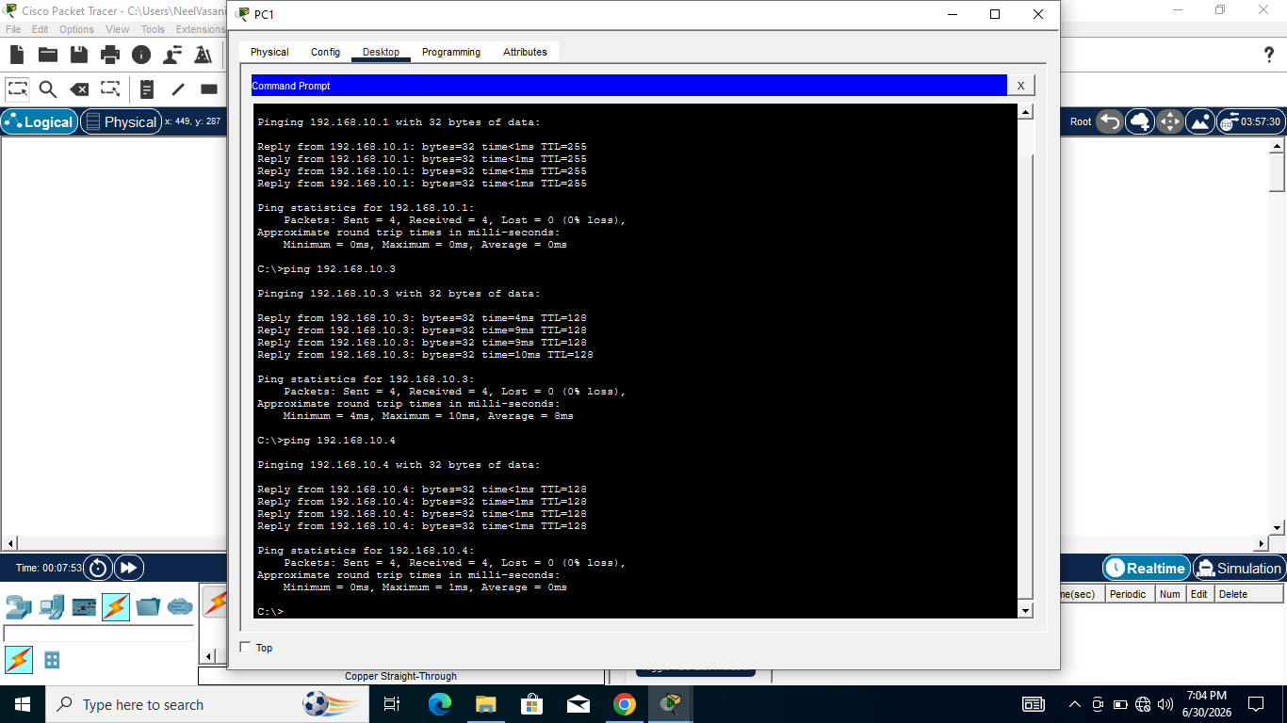

Screenshot 3

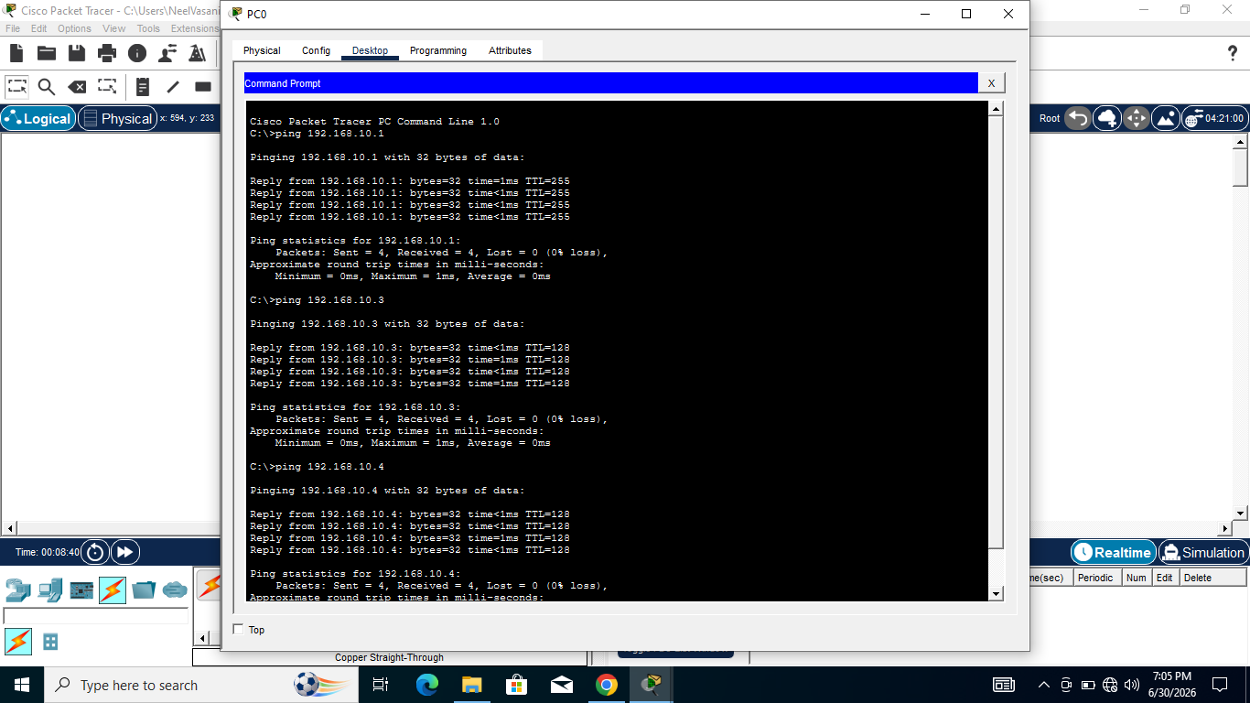

Screenshot 4

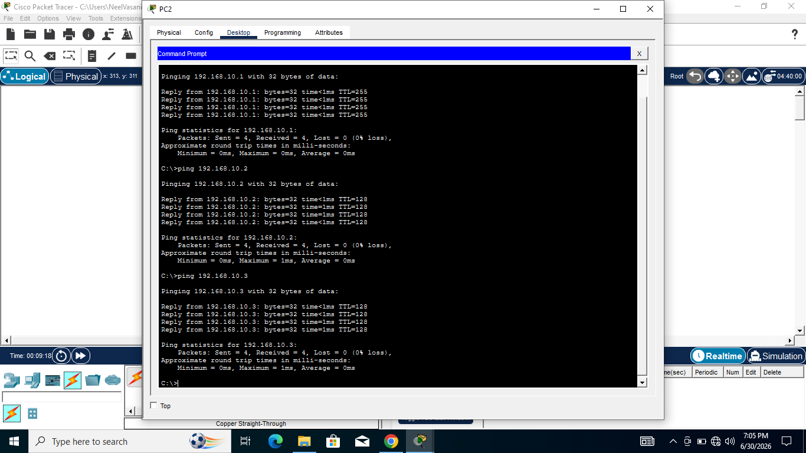

Screenshot 5

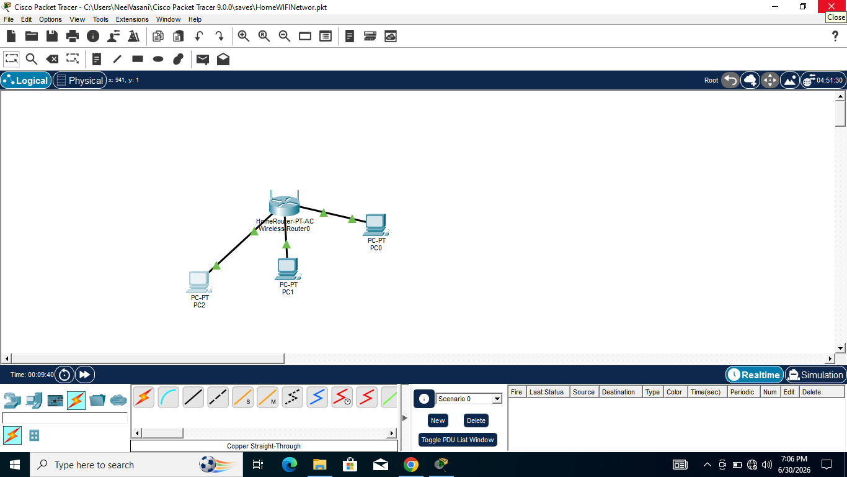

Conclusion
All devices were configured with static IP addresses on the same subnet. Ping tests confirmed successful communication between the PCs and the router.

